Mammal Adaptation Matching Quiz

Instructions: Match the animal to its adaptation. To complete this quiz, you must write your adaptation answer (the letter) next to the picture of the animal.
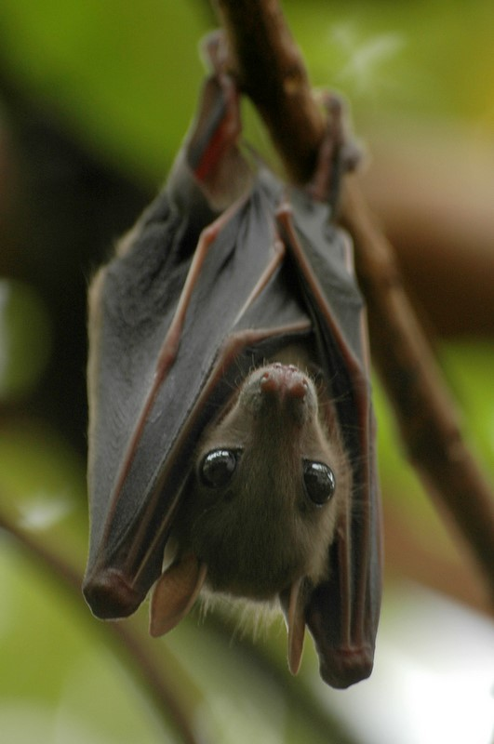

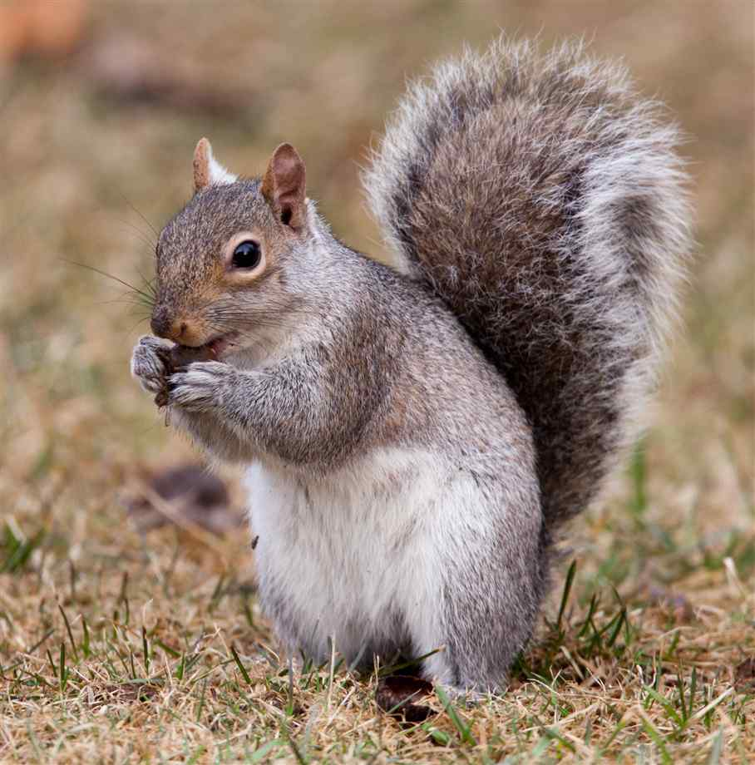

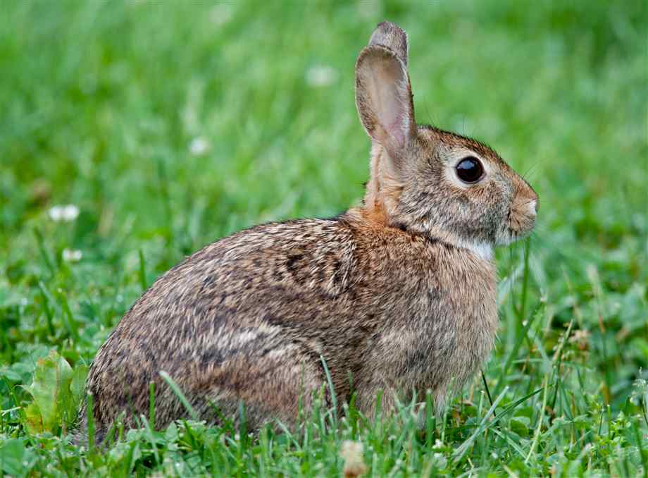

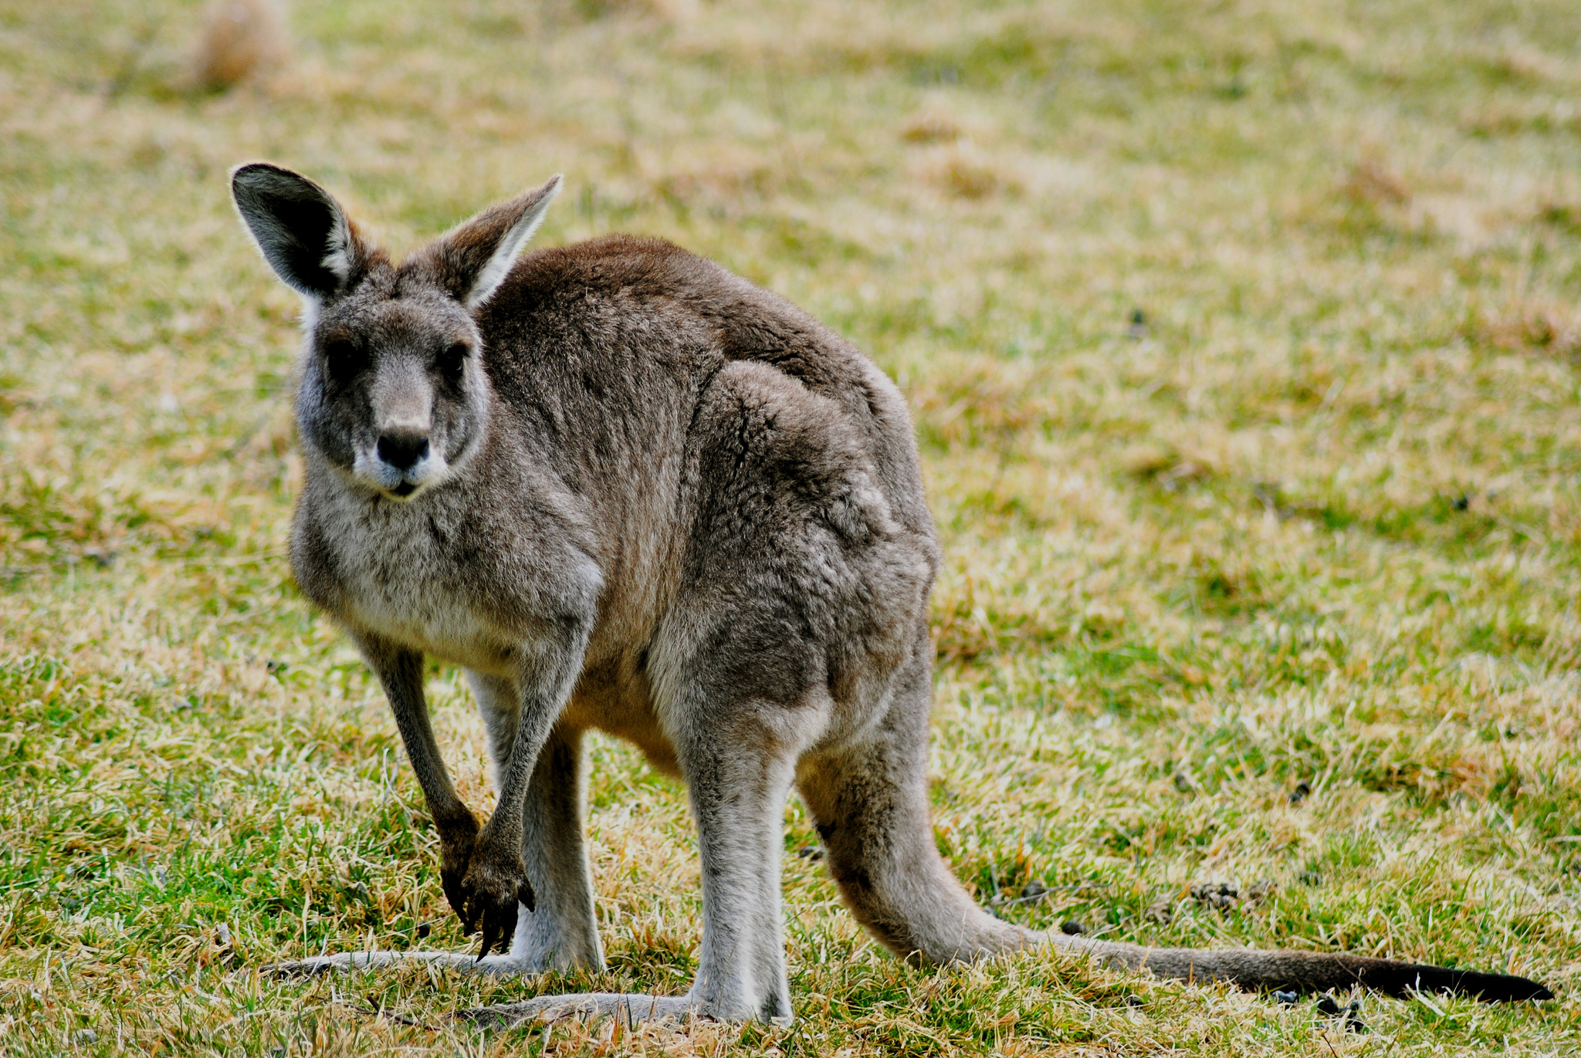

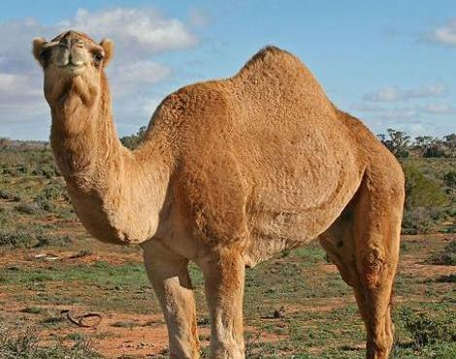

- Camouflage.

- Carry a lot of water in a hump.

- Have pouches.

- Store food and hibernate.

- Echolocation to fly.

